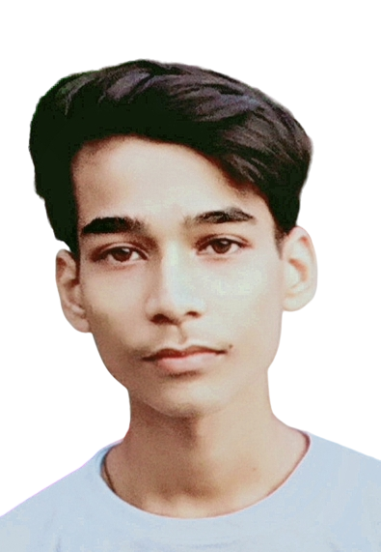
Resume

Vansh
Mob:- +918791144733
E-mail:- vanshkumar707878@gmail.com
Career Objective
To use my skills in the best possible way for achieving the company’s job. I want aa highly rewarding carrer where I skills and knowledge for organizational and personal growth.
Educational Qualification
Examination | Board/University | School/College | Year of Passing
10th | U. P. Board | Vishnu Inter College | 2020
12th | U. P. Board | Vishnu Inter College | 2022
Bachelor of Computer Application (BCA) | Mahatma Jyotiba Phule Rohilkhand University | Future Group of Institute | Pursuing
Computer Skills
. MS Office (Word, Excel, Access & Powerpoint).
. DTP ( Corel Draw, Page Maker & Photoshop).
. Internet (Mailing, Filling Form & online work).
. Basic knowledge of website Development
Core Strengths
• Technical Skills
• Team Work
Personal Profile
Father’s Name : Vinay Prakash Marital Status : Unmarried
Date of Birth : 14/03/2006 Address : 131, Jatvapura (Bareilly)
Language known : Hindi , English Gender : Male
Declaration
I hereby declare that all the information given above is true and correct to the best of my knowledge.

Date : Name

